Important Information
This document will serve as a guide to each spreadsheet that has been modified in order to accurately represent current data about the Hope House of Manitowoc County. Additionally, it will contain instructions about utilizing each tool, as well as a data dictionary, which will provide ample explanations about what each function is doing.

Suggestion: When navigating throughout this document, it is recommended to turn on the navigation pane to view certain information. The navigation pane can be enabled by selecting “View” on the upper ribbon. After selecting View, select the checkbox next to “Navigation Pane.” Now, labels for each option are viewable. When selecting the item you wish to receive more information on in the navigation pane, it will automatically travel to that space in the document. In addition, when selecting the arrows to the left of each heading, it will collapse parts of the document to access the information desired in a simpler fashion.

Data Dictionary
This Data Dictionary helps clarify what different information is utilized throughout the Deposit and Invoice Dashboard. The navigation pane will be helpful to navigate this document.

Creating a Chart

Pivot Table
A Pivot Table is the main item that helps generate the visual representations of the data. It is comparable to a traditional table, except for a few distinct properties, the most important of which are listed below.
-A Pivot Table can calculate partial sums for values, without the use of formulas.
-A Pivot Table can be perform calculations without the need for formulas, due to Data Slicing, which can be achieved with a Slicer

Pivot Chart/Pivot Chart Analyze
A Pivot Chart is a chart that is created based on a Pivot Table. The appearance of a Pivot Chart is exactly the same as a traditional chart. The only difference between the two, however, is the presence of the “Pivot Chart Analyze” tab when selecting either the Pivot Chart or the Pivot Table. This allows for customization for which data is viewable in the chart.
When selecting the “Pivot Chart Analyze” tab, several options appear. The most important of these include:
-Insert Slicer- creates a slicer so that only specific data from the Pivot Table will be selected. For example, if you would like to examine data from 2023, you could insert a slicer based on year and select 2023.
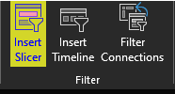
-Refresh- contains a drop-down menu, which can be accessed by selecting the arrow below
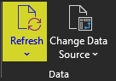

Slicer
A slicer narrows down the data to specific conditions in a Pivot Table. For example, if you would like to only examine values in the year 2020, a slicer could be utilized for the ‘Year’ column to make sure the chart reflects this initial condition (Shown below).
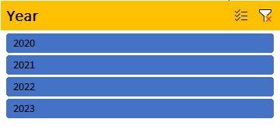
It is important to note that a slicer can be inserted for a Pivot Table. When a chart is based on a Pivot Table, the chart will update to reflect the data selected by the slicer.
When utilizing the slicers in the dashboards, multiple years can be selected. To do this, hold down the CTRL key and click on each year that you would like to display in the chart. To reset the filter, simply select the ‘Clear Filter’ button (Shown below).

Modifying a Chart

Design Tab
The design tab contains many different options to modify the design of a Pivot Chart. It is worth noting that this tab does not appear until a Pivot Chart is selected.
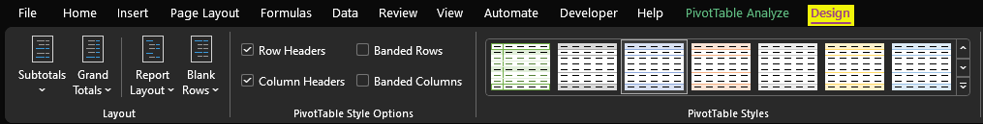

Format Tab
The Format tab appears when a chart is selected. It is utilized to modify the features on the selected chart. It has many options and generally will take experimentation to get the desired result. The most important of these are highlighted in the image below.
Key Features:
*Shape Fill- Changes the colors of items in the chart
*Shape Outline- Changes the outline of the items in the chart
*Shape Effects- Allows for modification of each item in the chart, such as 3-D effects, bevels, etc.
*Format Selection- Offers many options to modify the chart, including font, placement of labels, etc. By default, this tab will format the chart itself. Select the arrow to the right of chart options to change what will be modified. (Shown below)
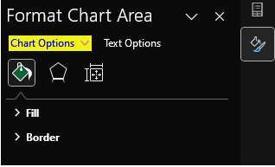

Pivot Chart Fields
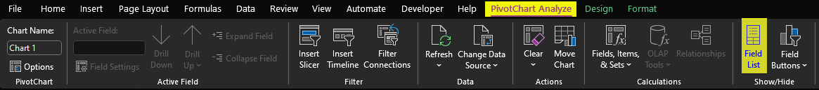
Pivot Chart Fields is a menu that will pop up after clicking on the ‘Field List’ option under the ‘Pivot Table Analyze’ tab. (Shown below)
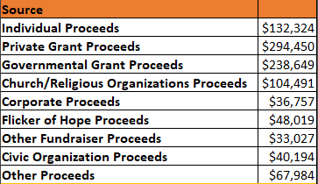
This menu allows a Pivot Table to be constructed with columns and rows based on a data reference. For example, the Pivot Table below is constructed based off of the ‘Raw Invoice Data’ sheet.
There are four different categories where you can drag-and-drop a column in to experiment with a Pivot Table. These include the following: filters, columns, rows, and values. Generally, values will be what is most often going to be used. When columns are entered into the values selector, an automatic row will be created based on the columns selected for values. The Pivot Table above utilizes the following fields, as demonstrated below.
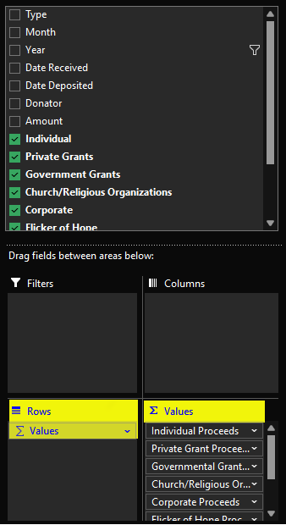

General

Extending Formulas
*When carrying formulas to more rows and columns, it is important to understand a couple of different properties of Excel. In an Excel document, there is a small green square in the corner of a selected cell. When clicking and dragging onto the cells that you would like to extend the formula to. If you would like a number to stay constant across the cells, you would add a dollar sign in between the number and the letter. Here is a good resource to learn about extending formulas.

Instruction Guide
This will serve as a supplement for the dashboards to help give instructions for any confusing and more complex ideas to modify the Excel documents to the most ideal state. The navigation pane is recommended to help navigate this document.

Adding Data to the Deposit/Invoice Dashboards

Important Information
Adding data into the Deposit and Invoice Dashboards is one of the most important steps to utilizing each Excel document.

Steps
- Navigate to the ‘Raw Invoice Data’ or ‘Raw Deposit Data’ sheet in the Excel document.
- Enter the data you wish into the table, ensuring that each of the data matches the columns. If the columns differ from the ones present, refer to the Adding a Column to the Deposit/Invoice Data heading.
- In order to fill in zeroes for the rest of the values, select all dollar amounts in the table by selecting the amount column, then holding down CTRL + Shift + Right Arrow key and then CTRL + Shift + Down Arrow key. This will select all values in the table.
- Once all the data is selected, press CTRL + H, which brings up a menu to replace values (Shown below)
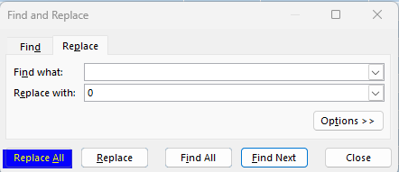
- Select ‘Replace All’ to replace all values with $0.00
- If the values are not currencies, select all data again with the same method shown above and then convert the value to a currency. Select the arrow to bring up a drop-down menu and select currency. (Shown below)
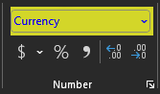

Adding a Column to the Deposit/Invoice Data

Important Information
Adding a column is a critical skill for making the data customizable for ever-changing situations.

Steps
- Navigate up to the top of the Excel document in the sheet entitled ‘Raw Invoice Data’ for Invoices or ‘Raw Deposit Data’ for Deposits.
- In the row of letters, in the final column that contains data, right click, and select ‘Insert’.
- This will insert a column and instantly resize the table to match the data.
- This column can be moved simply by left clicking on the letter matching the column, which will select all of the desired data.
- Right click on the selected data and choose ‘Cut’.
- Move the mouse to where you would like to place the cells and right click.
- Select ‘Insert Cut Cells’. If prompted, shift the cells to the right or to the left, depending on where you would like the column placed.

Adding More Rows to Deposit Data Table

Important Information
As the document stands, there is maximum of 5000 rows for the Raw Invoice Data and Raw Deposit Data tables. However, this can be simply modified by following the steps listed below.

Steps
- Select any cell in the table to modify.
- At the top ribbon, select ‘Table Design’.
- In the ‘Table Design’ tab, there will be an option on the left to resize the table.
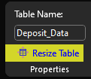
- Select the ‘Resize Table’ option and then update the very last number, which should currently read 4999 or any value that it has been previously set to (Shown below). Change it to the desired number of rows. Note: The larger the number of rows in this data table, the longer it will take for the document to open. The document will likely become very laggy the higher the value is.
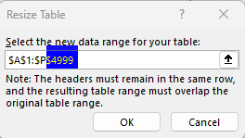
- Select ‘OK’ and then the table should be resized! If not, ensure that the dollars sign is present before each letter and number in the formula, so that it matches the format above.

Modifying Data in the Deposit/Invoice Dashboards

Important Information
Modifying data is another very important part of the Deposit and Invoice Dashboards. Thankfully, it is fairly straight-forward, which is always a good thing.

Steps
- Change any values in the ‘Raw Deposit Data’ or ‘Raw Invoice Data’ tabs to reflect current numbers.
- Note: These values will not change the charts or Pivot Tables right away. Follow the process for refreshing the Deposit/Invoice Dashboards, which is on the next page. This will update the charts to reflect the modified data.

Refreshing the Deposit/Invoice Dashboards

Important Information
Before refreshing the charts, ensure that the formatting is consistent with the rest of the data present. If not followed similarly, the charts will not refresh. Refer to the “Adding Data to the Deposit/Invoice Dashboards” section for clarification about correctly inputting, modifying, and adding new data.

Steps
- After your new data is entered, navigate to the Deposit/Invoice Dashboard, where a summary of current data can be found.
- Once on the Dashboard, click on each chart to select it.
- When the chart is selected, navigate to the upper ribbon, which will have the option “PivotChart Analyze”. Select this option.
- Several options will appear. The one that needs to be selected to update the chart is “Refresh.”
- Once the Refresh option has been selected, the chart that was selected will now be updated to reflect the most recent data.
- Navigate up to the ribbon and click on “File” -> “Save”

Creating a New Table for the Deposit/Invoice Dashboards

Important Information
This is likely one of the most important steps in creating a representation of the current data. It will be one of the more complex pieces of utilizing the dashboards.

Steps
- Navigate to the ‘Raw Invoice Data’ or ‘Raw Deposit Data’ sheets in the Excel document.
- Once in the sheet, go to the top ribbon and select ‘Insert’
- In the ‘Insert’ tab, there will be an option for ‘Pivot Table’. Just below this option, an arrow will be present. Select the arrow and click ‘From Table/Range’.
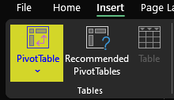
- When selecting the range, it should default to ‘Deposit Data’ or ‘Invoice Data’. If not, navigate to the very top of the worksheet and select the leftmost value, which will likely be A2.
- Press CTRL + Shift + Right Arrow and then CTRL + Shift + Down Arrow.
- This should select all data present in the table.
- In the menu, select ‘New Worksheet’ if it is not already selected, like the image below.
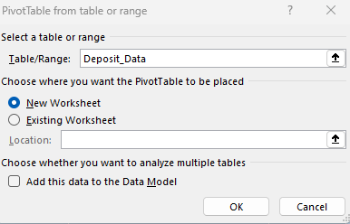
- After this step is complete, a new sheet should be created where options can be dragged and dropped, just like a Pivot Table. If confused about adding values, refer to the Data Dictionary, where Pivot Tables are explained in more detail. It will briefly explain how fields work so you can create the chart you are looking for.

Creating a New Chart for the Deposit/Invoice Dashboards

Important Information
In order for a new chart to be created for the dashboards, it will need to be based on either a table or a Pivot Table.

Steps
- Select the data that you would like to create a chart for.
- On the top, select ‘Insert’ and then select the chart type (Shown below)
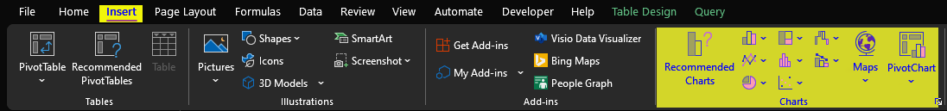
- If you are unsure of the chart type that you would like, select ‘Recommended Charts’ and it will provide different options of charts, based on the data that is currently selected.
- Utilize the Design and Format tabs when the chart is selected to modify it to represent what you would like for the chart.

Adding Data to the Grant Tracker

Important Information
Formatting is not necessary for this spreadsheet and can be changed at any time. Additional columns can be added as needed.

Steps
- Enter initial information about the grant, such as the check number, date received, initial amount, etc.
- After the initial amount is entered, each column will update to reflect new changes.
- As the grant money is utilized, enter the information can be entered accordingly. It is important that the value in the “Total Amount Remaining” column is not changed, as it will undermine the calculations to denote the remaining value of a grant.
- If at any point the utilization of the grant money exceeds the number of rows currently present, select the last currency value in the “Total Amount Remaining” column.
  - Once the value is selected, move your cursor to the bottom right corner of the highlighted cell.
  - When hovering over the cell’s corner, a black “plus sign” will appear.
  - While ensuring that the “plus sign” is visible, drag down the number of cells needed with your mouse. This will carry the formula across more cells.
- Navigate up to the ribbon and click on “File” -> “Save” when finished entering data.

